**Spike and Drip Chamber**

* Metal filter
* Metal spike
* Plastic spike
* Soft plastic drip chamber
* Detachable filter in a cone shape that screws in with the lid
* Metal filter that lays flat in the bottom of the drip chamber

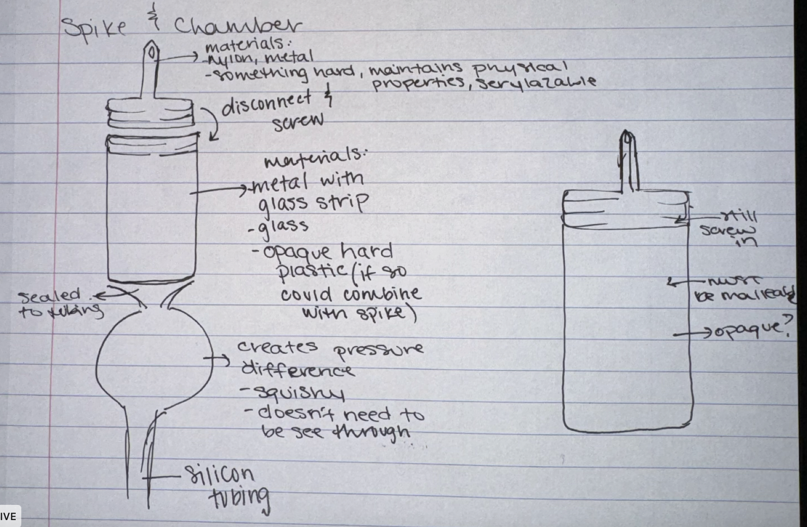

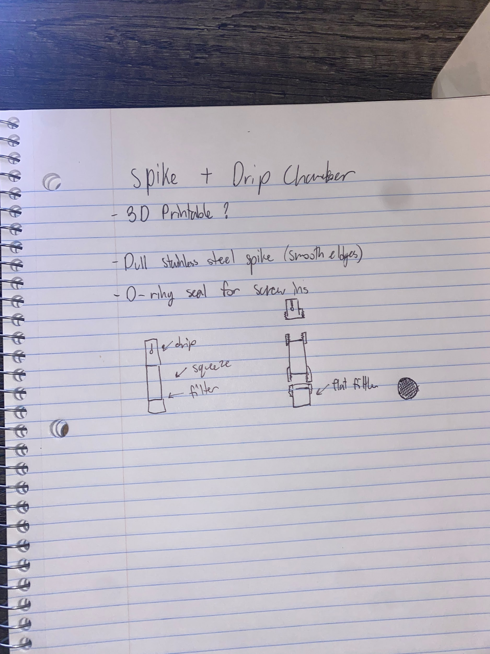

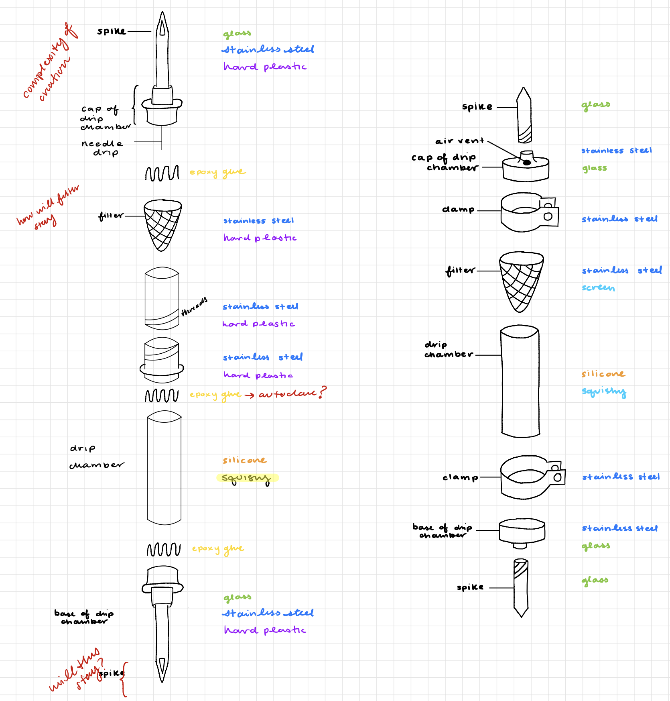

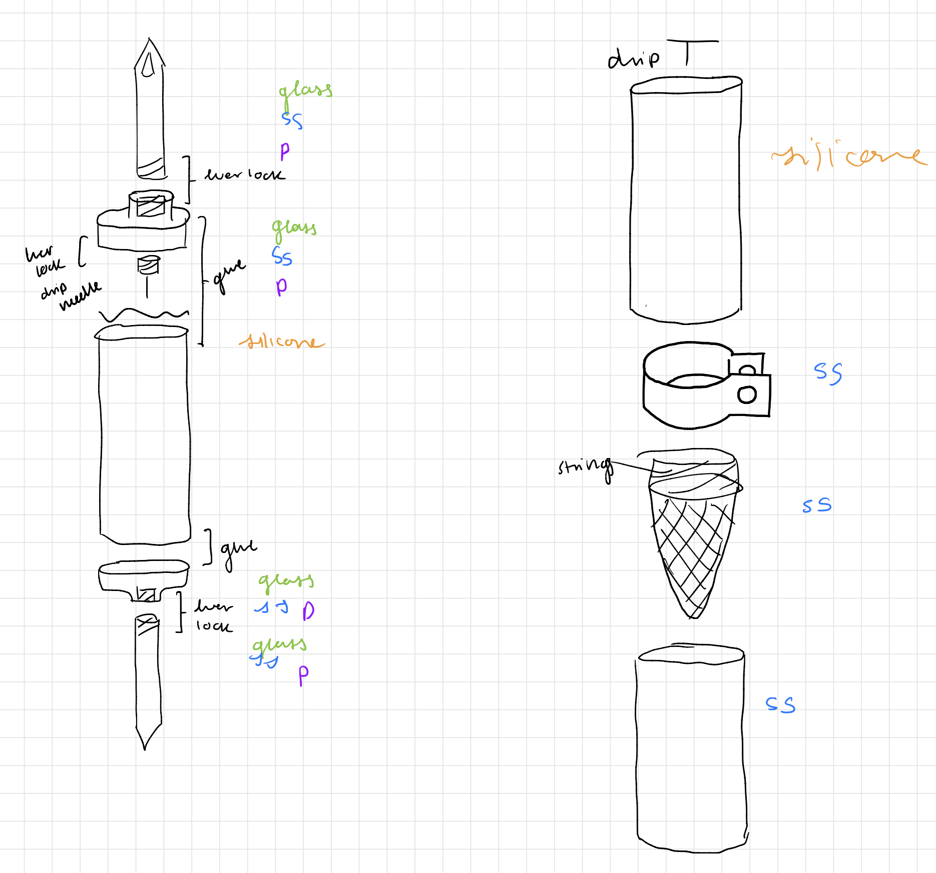

**Tubing**

* Platinum cured Silicone tubing
* Hard PVC/plastic tubing
* Metal tubing - similar to metal straws
* Metal linkage tubing

**Connections**

* Glue + metal connectors
* PVC connectors, press to fit
* Tape - untaped every time, replaced every use
* Tubing clamps
* Masterbond epoxy adhesive ~ or equivalent

**Flow Regulator**

* Zip tie
* Metal clamp
* Twist tie mechanism
* Clothes pin

